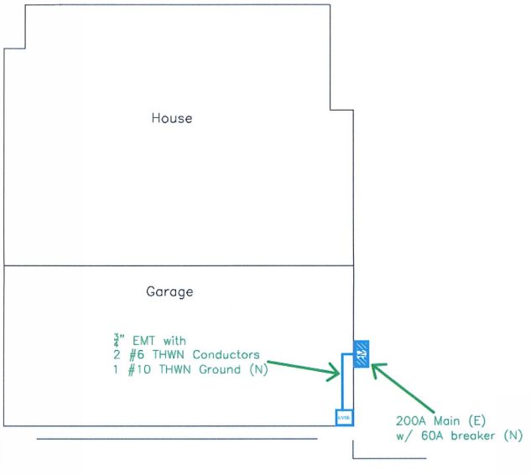
SCOPE OF WORK:
DATE:
REVISION:
SCALE:
SHEET:
User tip1: edit or delete red text depending on project scope.

User tip 2: import graphical elements or photos as JPG, and set layouts to be In Front of Text
Type description of proposed work here to include all architectural and structural aspects, which shall match that in the permit application.
PROJECT DATA:
Occupancy Group: R-3/U
Construction Type: V-B
Number of stories: #
Existing fire sprinklers: Yes/No
Total square footage: ### ft²
Altered square footage: ### ft²
Applicable codes:
2022 California Residential, Mechanical, Electrical, Plumbing, Fire, Energy, CALgreen and Menlo Park Municipal Codes
Sheet index:
1 – Coverpage and project data
2 – Title

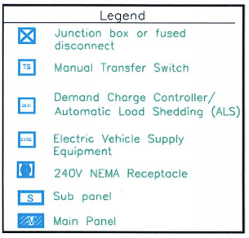
11x17 Plan Template MP 20230817
CITY APPROVAL STAMP
DRAWINGS BY:
DESIGNER NAME
Designer Signature
XX
MM/DD/YYYY
1 of #
NTS
TITLE FOR FIRST PAGE

HOMEOWNER NAME
STREET ADDRESS
MENLO PARK, CA 94025
DATE:
REVISION:
SCALE:
SHEET:
CITY APPROVAL
11x17 Plan Template MP 20230817
Architectural Notes:
All existing windows and doors shall remain.
Mechanical Notes:
Energy star-rated exhaust fan with a minimum 50 cfm (intermittent) or 20 cfm (continuous) venting directly to the outside, with humidity (50-80%) control. CRC R303.3.1 and CGBSC 4.506.1
Plumbing Notes:
1. Shower doors shall open so as to maintain not less than a 22-inch unobstructed egress opening. CPC 408.
2. Shower and tub/shower walls shall be finished with a nonabsorbent surface (e.g., ceramic tile, fiberglass, etc.) over a moisture resistant underlayment (e.g., water resistant gypsum board, green board, etc.) to a height of 6 feet above the floor. CRC R307.2 and R702.3.7
3. Prescriptive maximum flow rates
Showerheads ≤1.8 gallons per minute (gpm) @ 80psi
Lavatory faucet ≤1.2 gpm @ 60psi
Water closet ≤1.28 gallons per flush
Electrical Notes:
1. All bathroom receptacles shall be GFCI and at least one shall be within 3 feet of the outside edge of each basin and on the wall that is adjacent to the basin. CEC 210.8(A)(1) and 210.52(D)
2. Light fixtures in tub/shower enclosure shall be labeled “suitable for damp locations.” CEC 410.10
3. At least one luminaire in each of the bathroom shall be controlled by a vacancy sensor. CA Energy Code 150.0(k)2J
4. Recessed luminaries shall be IC- and AT- rated, accessible from below the ceiling, and JA8 compliant. CA Energy Code 150.0(k)1C
additional notes:
Type notes here.
MM/DD/YYYY
1
NTS
A2
HOMEOWNER NAME
STREET ADDRESS
MENLO PARK, CA 94025
DRAWINGS BY:
DESIGNER NAME
Designer Signature
TITLE FOR SECOND PAGE

